API Documentation

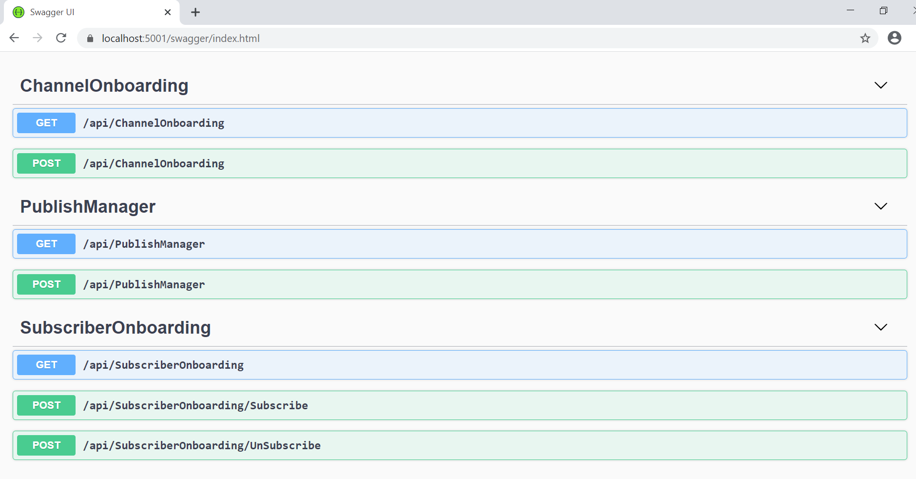

Domain Models

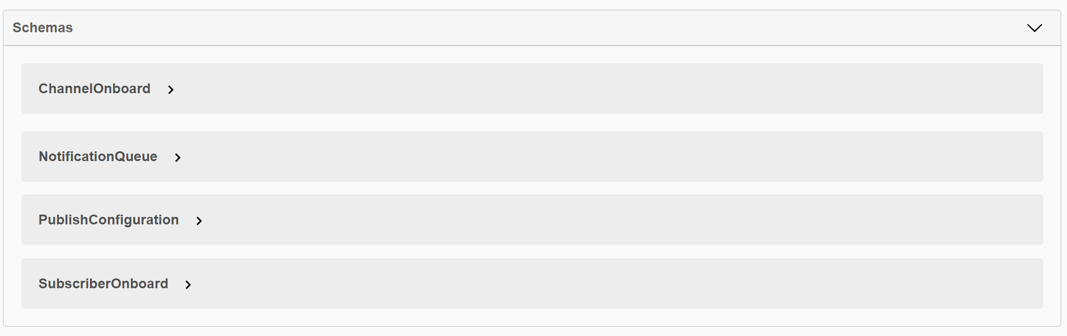

Contracts as follows

1. Get all channels

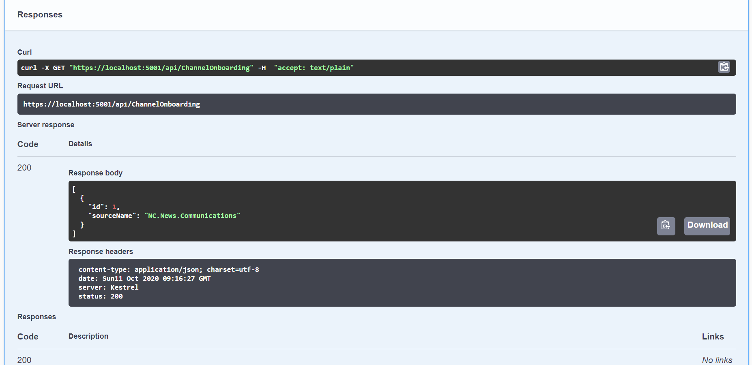

1. On board new channels

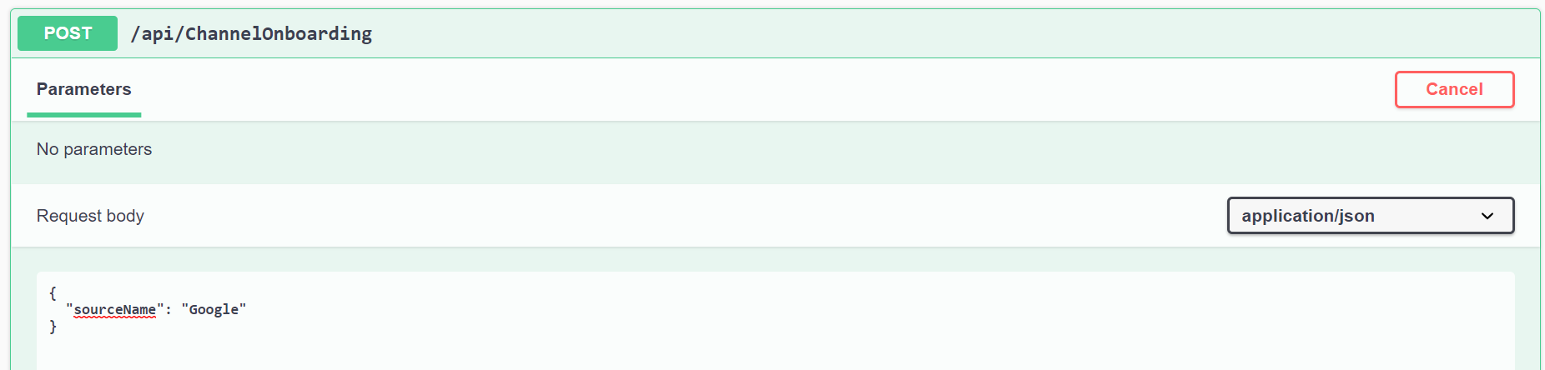

Verify –

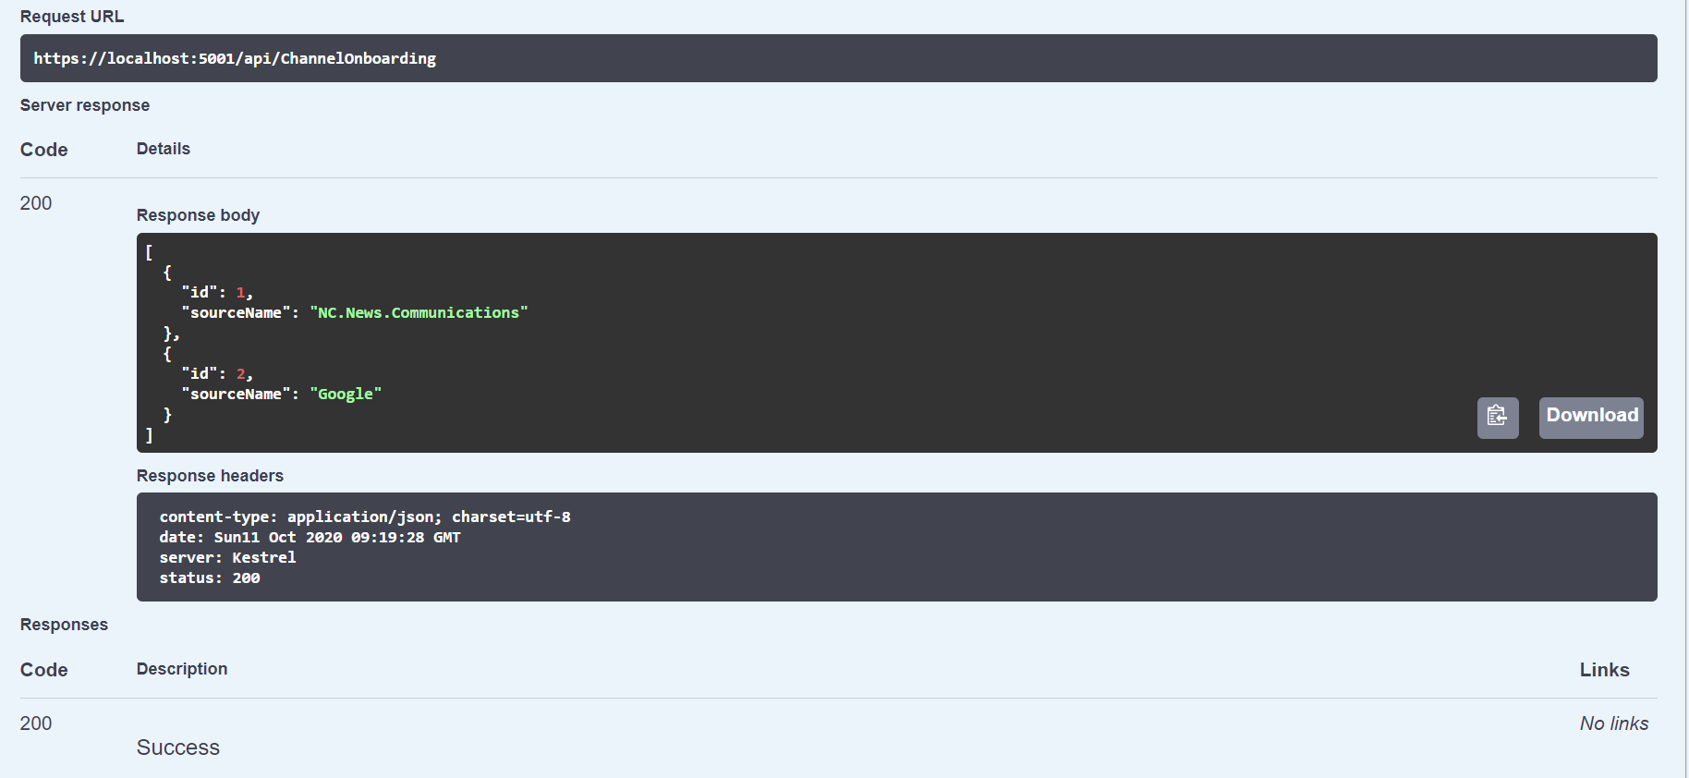

1. Subscribers enrollment

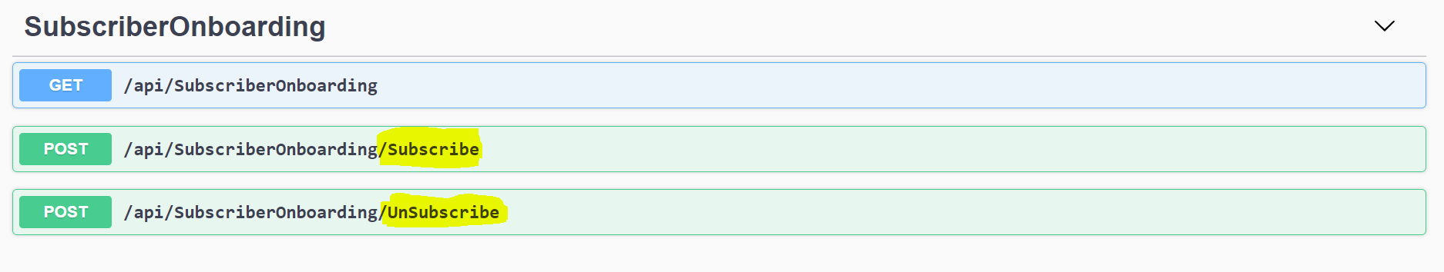

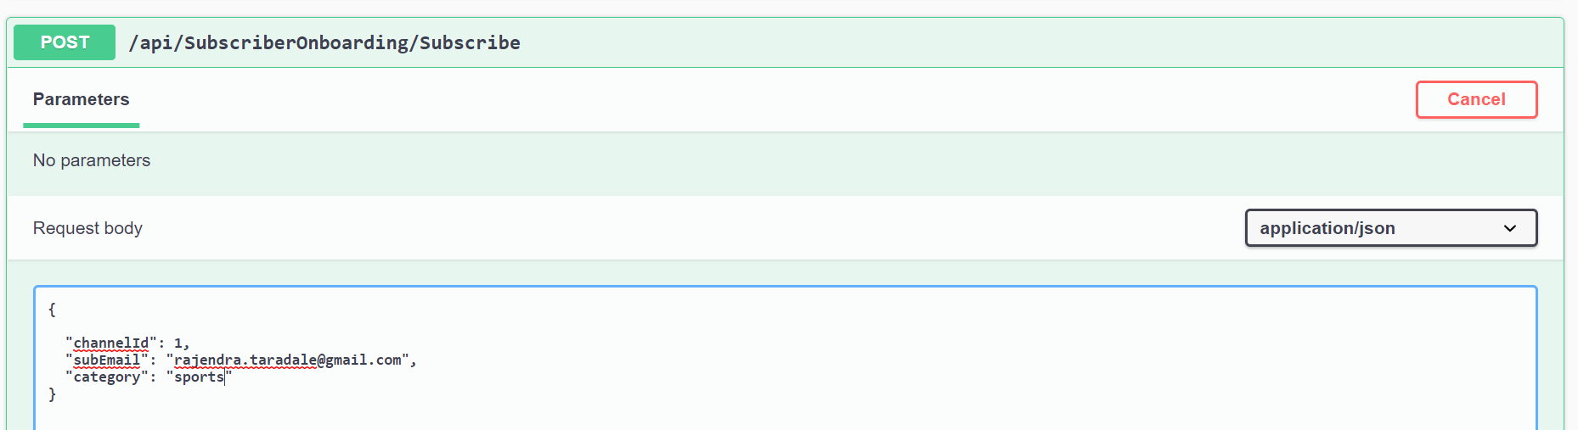

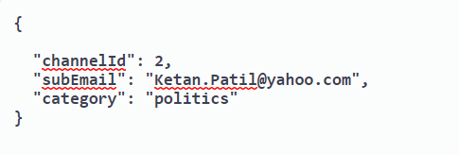

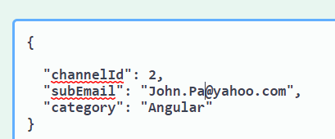

Verify –

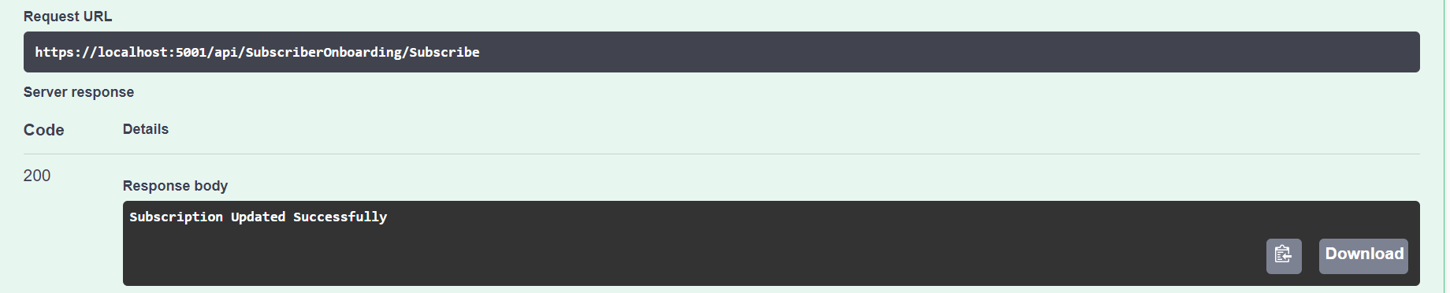

Verify all Subscribers

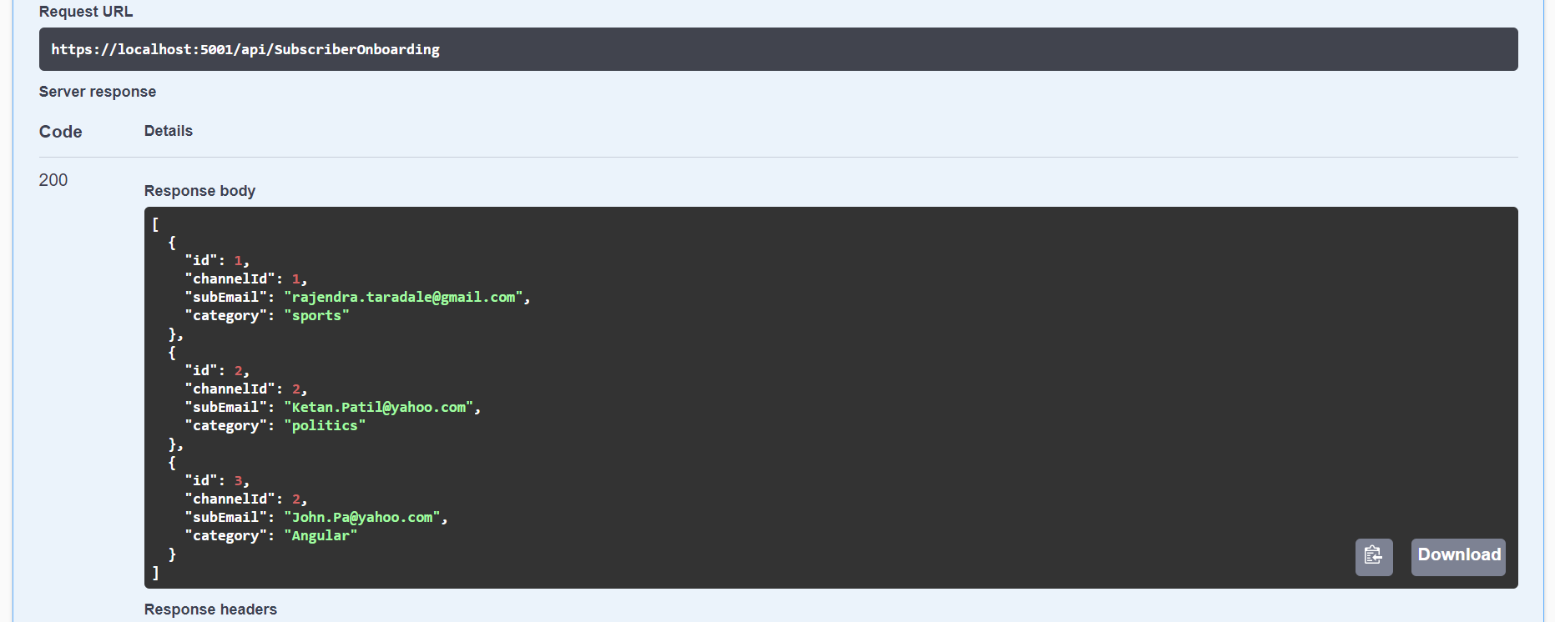

Configure the message publication time and intervals

sourceNotificationInterval – every two seconds custom messages will published and recipients will receive message as per next screen -

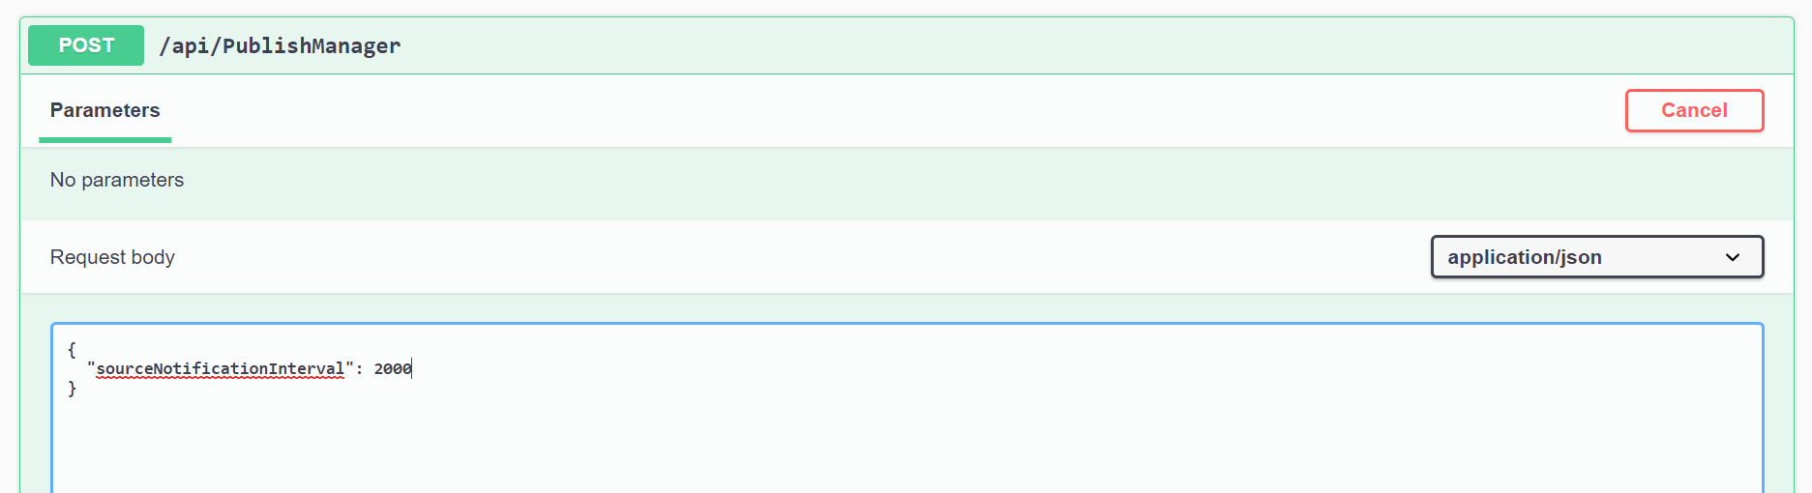

Sample messages delivered

